Umatilla County Soil and
Water Conservation District



2006-2007

Business Plan

Executive Summary

The purpose of the Umatilla County Soil and Water Conservation District (SWCD) Business Plan (Plan) is to serve as a broad outline for the Umatilla County SWCD to follow when guiding its directors, employees, and partners in response to natural resource concerns, internal and external practices, and other factors that influence courses of action. This Plan has been formatted so that it performs the functions and incorporates the concepts and contents associated with both the long-range and short-term strategic goals.
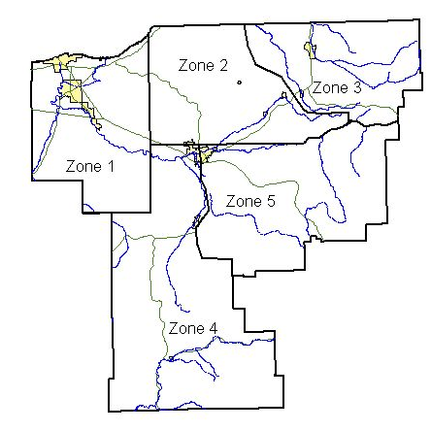

Umatilla County SWCD established in 1974 with the consolidation of the West, Southern and East Soil Conservation Districts, encompasses the whole of Umatilla County, Oregon. Umatilla County has a population of 70,900 and encompasses 3,231 square miles and is bounded by the Columbia River on the north, Morrow County on the west, Grant County on the south, and Union and Wallowa Counties on the east. Lying to the southeast is The Umatilla Indian Reservation which was established by the Treaty of Walla Walla in 1855. It became an 800 square mile home for the Umatillas, Walla Wallas, and Cayuse tribes. McKay Reservoir with a useable storage capacity of 321,000 acres/feet is located in the eastern part of the county. More than 200 different agricultural cash crops on 164,307 acres are produced in Umatilla County.

The Umatilla County Soil and Water Conservation District takes the lead in soil and water conservation throughout Umatilla County by working with urban and rural property owners, operators, public officials, various state and federal agencies, and private organizations. This District believes in the protection, conservation, and improvement of soil and water through our employees’ and directors’ abilities to plan, assist, and educate. It is our belief that concerns about water quality, water quantity, wetlands, soil erosion, and weed management be addressed while simultaneously respecting the private property rights of the property owner and operator. These concerns are addressed through the adoption of this Plan and by maintaining existing agreements with the various agencies that work with this District.

Table of Contents
Introduction 4
Strategic Direction 4
Mission 4
Vision 4
Values 4
Concerns 5
Natural Resource Concerns 5
Areas of Special Concern ____________________________________________________ ________5
Goals and Objectives 6
Goal 1: Promote a helathy, sustainable natural resource based economy 6
Goal 2: Manage the Business of the District 6
Leadership 6-7-8
Partnerships 9-10-11
Capabilities 11-12-13
Calendar of Board Events ______________________________________________________ 13
Appendix A (Acronyms and Terms) 14
Appendix B (History) 15-17
Appendix C (Programs) 17-18
Appendix D (Enabling Legislation and Governance) 29-20
Appendix E (ORS 568.210-568.890) 21-22
Appendix F (ORS S 568.550) 23-24
Appendix G (Related Statues and Administrative Rules) 25

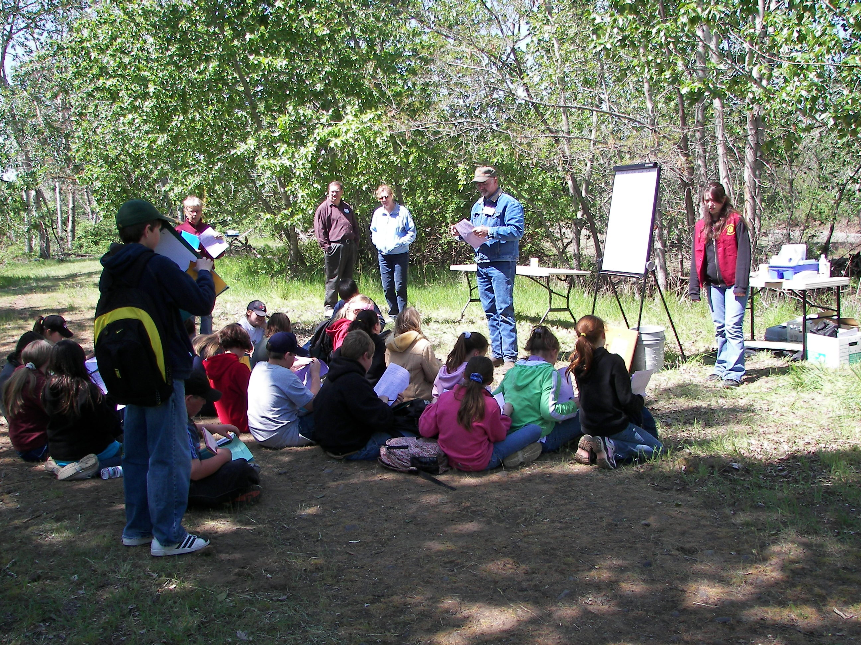

Watershed field days “06”

Introduction
This Business Plan was approved by the Umatilla County SWCD Board of Director and developed to direct the programs, activities and operations of the Board of Directors and employees as a “road map” for their activities from the period July 1, 2006 through June 30, 2007. This Plan guides the development of the District annual budget and work plan (copies are available in the Umatilla County SWCD office and online at www.umatillacountyswcd.com). It is organized into eight major sections and seven appendices. It will be reviewed annually for possible updates to reflect changing circumstances according to the District’s adopted planning cycle.
Strategic Direction
Mission
The mission of the Umatilla County Soil and Water Conservation District is to conserve, protect, and develop soil, water, and other natural resources for the economic and environmental benefit of the residents of Umatilla County. In carrying out our mission, the Umatilla County SWCD works, coordinates and cooperates with:
- property owners and operators
- public and private conservation organizations
- agricultural groups
- public agencies
- citizens
Vision
The vision for Umatilla County SWCD includes transition to broader service, broader use of technology, and networking with Natural Resource Agencies to provide landowners easy access to a variety of assistance for natural resource protection and conservation, while maintaining the goals of our mission statement.
Values
The Umatilla County SWCD values:
- the proper administration of district funds
- quality customer service
- the capabilities and contributions of the Umatilla County SWCD staff
- the economic importance of agriculture and natural resources to our community
- the respect, trust, confidence and confidentiality of all property owners/operators
- a voluntary, common-sense approach to problem solving rather than a bureaucratic or regulatory approach
- the stewardship of soil and water
- the application of science and research
- communication with the public and within the office infrastructure
- managed use of natural resources
Concerns
Natural Resource Concerns
- Water Quality
- Waterbodies classified as on the DEQ 303(d) water quality limited list
- Discharge of pollutants into lakes, ponds, rivers and streams
- Contamination of surface and ground water caused by various practices and sources
- Improper operation of drainage and irrigation ditches
- Inappropriate use of fertilizers and pesticides

- Water Quantity
- Declining groundwater tables and slow groundwater recharge due to area geology
- Declining amounts of surface water available for beneficial uses
- Decrease in fish and wildlife habitat
- Soil Erosion
- Irrigation-induced erosion
- Bare soil during rainy seasons
- Lack of healthy riparian vegetation or buffers
- Improper application of management practices

- Weed Management
- Lack of noxious weed control
- Loss of native groundcover
- Contamination of crops

Areas of Special Concern
Specific problems that may need special attention are:
- Possible nonpoint source pollution from eroding agricultural and forest lands, eroding streambanks, runoff and erosion from roads and urban areas, runoff from livestock and other agricultural operations and septic systems.
- Water quality issues in the Lower Umatilla Basin Groundwater Management Area.
- Implementation of the January 2005 soil erosion and sediment control rules for non-HEL soils.
- Lack of education on soil and water conservation
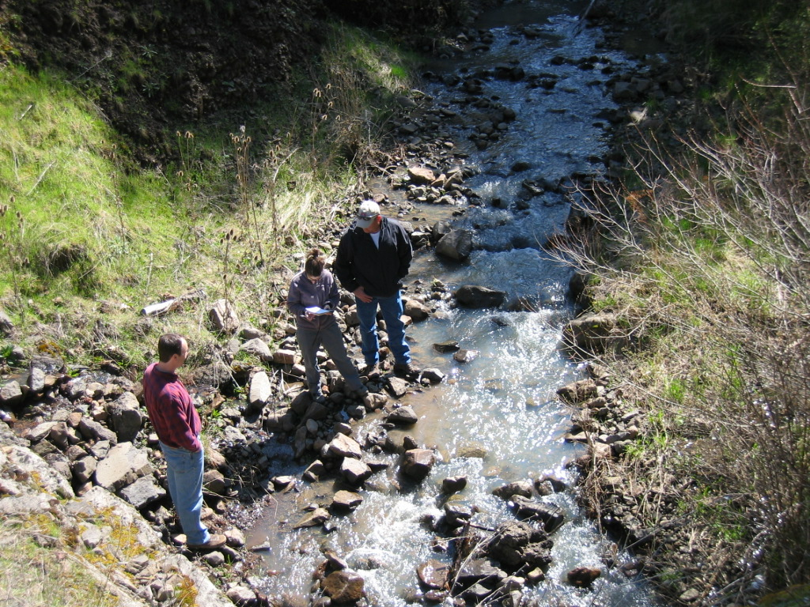
Sampling on the Wildhorse

Goals and Objectives
Management of all natural resources, including water, land, air and other resources are important for sound environmental stewardship.

Promoting a healthy, sustainable natural resource based economy
- Protect and improve Umatilla County’s air, soil, wildlife, timber, and water resources in concert with agriculture, recreation and urban uses,
- Improve landowners management of natural resources ensuring both economic and resource sustainability,
- Increase adoption of integrated crop-livestock production systems to improve farm profitability and environmental quality,
- Increase the adoption of practices that reduce nitrate export from subsurface drainage,
- Increase the understanding of water quality issues and problems associated with poor stewardship practices,
- Identify site-specific strategies (grants) and facilitate the implementation of these strategies to improve air and soil quality and address concerns,
- Change the attitudes and practices of how landowners use and protect natural resources.
Managing the business of the District
- Administer programs of the District,
- Provide technical and information resources to the public and partners,
- Capacity building,
- Secure adequate, stable funding for District operations,
- Retain competent, reliable staff,
- Recognize outstanding contributions to resource conservation,
- Develop and maintain cooperative partnerships,
- Maintain organizational structure,
- Maintain accountability
Leadership
The 2006-07 Umatilla County SWCD Board consists of seven voting Directors:
- Phillip Walchli (Zone 1)
- Berkeley Davis (Zone 2)
- Cheri Cosper (Zone 3)
- Charles Hemphill (Zone 4)
- Thomas Straughan (Zone 5)
- Robert Rosselle (At Large)
- Louie Dick (At Large)

These Directors are elected by the electorate of Umatilla County at the November General Election, which is held during even numbered years. Director positions are elected in staggered terms to provide continuity on the board and maintain operational consistency. The Umatilla County SWCD Board may appoint a person to fill a board vacancy between elections. Five of the seven positions are classified as zone positions and must meet the zone requirements and terms of office as specified in ORS 568.560 as follows:
“Zone directors must own or manage 10 or more acres of land in the District, be involved in the active management of that property, reside within the boundaries of the District, and be a registered voter.”
An individual may serve as a zone director in lieu of the land ownership or management requirements if the individual resides within the zone that is represented, has served at least one year as a Umatilla County SWCD Director or Associate Director and has a conservation plan approved by the Umatilla County SWCD Board. The other two positions are at-large positions. To qualify for an at-large position, a person must reside in Umatilla County and be a registered voter. No land ownership or management requirements are needed for an at-large position, which is also governed by ORS 568.560.

If a Umatilla County SWCD Director ceases to meet the eligibility requirements while serving in his/her current position, the directorship must be surrendered. The Director does continue to serve until a successor has been elected or qualified, or until the Board declares the position vacant pursuant to ORS 568.560. The Board may fill a vacancy that occurs between General Elections by a majority vote of the remaining board members. An appointed director must meet the same eligibility requirements of an elected director as previously detailed.

If a Umatilla County SWCD Director is not attending publicly advertised meetings and has missed at least three consecutive meetings, the Board may request the position be declared vacant by the Oregon Department of Agriculture (ODA). ORS 568.560 states:
“Upon written recommendation of a majority of the members of the local governing body of a District, the department may declare vacant the position of any director who is absent from three consecutive meetings of the local governing body of the District.”
An individual director has power only when acting as a part of the Umatilla County SWCD Board. Individual board members may be given authority or power to act on behalf of the Board in specific, limited tasks. This authority or power is granted through board action (resolution, motion, policy, etc.) and must be recorded in the meeting minutes. The Umatilla County SWCD has chosen to limit or grant authority to individual board members and employees through the Board adopted Delegation of Authority.

The Umatilla County SWCD Board works cooperatively as a unit to plan and oversee implementation of district programs. As a representative of the District Board, opinions expressed publicly by individual board members should be consistent with established board policy, not the individual’s personal agenda or opinions.

ORS 568.545 requires all districts to select a Chair and Secretary from among its directors. The Umatilla County SWCD has decided to elect a Vice-Chair and Treasurer.
Umatilla County SWCD has also decided to appoint committees as needed.

The Chair is granted the responsibility to represent the District with other districts, agencies, associations, partners, organizations, legislators and property owners consistent with the policies, plans and interests of the District. The chair will also conduct regular and special meetings of the Board.

The Vice-Chair has been given the authority to act as the Chair in case of the absence or unavailability of the Chair.

The Secretary/Treasurer has the responsibility to oversee the financial transactions of the District and sign documents approved by the District Board.

Committees are an effective way for the District to plan and implement district functions. They can be comprised of board members, associate directors, and district advisors, representatives of cooperating agencies and associations or interested citizens. The Umatilla County SWCD has two standing committees, the Budget Committee and the Personnel Committee.

The Budget Committee was developed to research, investigate, report and recommend to the Board in the areas of budget setting, financial and accounting practices, and other administrative activities and policies and processes.

The Personnel Committee was developed to research, report and recommend to the Board in the areas of hiring of personnel, setting salary and benefits and other administrative activities and policies.

The Umatilla County SWCD also uses ad hoc committees, which are charged with specific tasks over a specific time period. Ad hoc committees are then disbanded after the assigned task and/or timeframe is completed.
The Umatilla County Soil and Water Conservation District expands its capabilities through the selection and appointment of Associate Directors. The 2006 Associate Directors are:
- Dinah Hemphill
- Teresa Walchli
- Tim Spratling

Associate Directors do not vote on board decisions but are expected to augment the Board’s knowledge and experience level and assist with District programs and activities. They may also be asked to represent the Board on specific assignments. Associate Directors, once officially appointed by the District Board, are provided with the same Tort liability insurance under the Oregon Tort Claims Act as the elected directors. Associate Directors are expected to attend monthly board meetings and other special meetings as requested. Associate Directors serve until the Board meeting on the January following the General Election, at which time the Board determines who they wish to appoint or reappoint.
Partnerships
The Umatilla County SWCD works closely with and maintains partnerships with many natural resource organizations and partners in order to complete our mission. These partnerships and collaborations are formalized by various means including but not limited to Memorandums of Agreement, Memorandums of Understanding, Working Agreements, Intergovernmental Agreements and informal agreements.

Natural Resources Conservation Service (NRCS)
The Umatilla County SWCD works with the United States Department of Agriculture (USDA) NRCS to provide technical assistance in designing and implementing conservation practices throughout the District, approval for NRCS local practice plans, administrative services for local field staff and business and annual work plan development through a Memorandum of Agreement.

Farm Service Agency and Rural Development
FSA’s mission is to stabilize farm income, help farmers conserve land and water resources, provide credit to new or disadvantaged farmers and ranchers, and help farm operations recover from the effects of disaster. FSA provides aerial photos for use in conservation planning work done by Umatilla County SWCD and NRCS. RD helps to improve the economy and quality of life in rural areas by providing financial assistance, economic development, housing programs, community empowerment programs, and essential public facilities and services.

Property Owners/Operators
The Umatilla County SWCD assists property owners/operators with conservation planning, technical and/or financial assistance, cooperator agreements, farm bill program opportunities, needs assessments and conservation-related questions through various working agreements.

Watershed Councils
The Umatilla County SWCD provides technical and administrative support, as resources allow, to the watershed councils located within our district. It may also serve as fiscal management agency for grant administration and collaborates with planning and projects as appropriate and requested.

Oregon Association of Conservation Districts (OACD)
The Oregon Association of Conservation Districts assists the Umatilla County SWCD by serving at the state level and speaking for issues relating to the District. It cooperates with other public and private organizations, with purposes similar to the Umatilla County SWCD, to adopt statewide policies and programs, which will effectively contribute to a quality environment and a productive economy.

Oregon Department of Agriculture (ODA)
The Umatilla County SWCD receives overall administrative oversight, partial administrative and technical support funding and small grant funding from the Natural Resources Division of the Oregon Department of Agriculture. This division of ODA reviews and approves or disapproves all projects, practices, budgets, contracts and regulations of the Umatilla County SWCD. ODA will keep the Directors informed of the activities and experiences of other districts assist in the exchange of advice and information among the districts and promote cooperation among the districts. The Natural Resources Division will help coordinate the various programs of the Umatilla County SWCD and solicit the cooperation and assistance of other departments of federal and state government. The Umatilla County SWCD functions as the Local Management Agency (LMA) for SB1010, specifically the Agricultural Water Quality Management Act, 1993 and the Umatilla, North John Day , and the Walla Walla Subbasin Agricultural Water Quality Management Area Plans. The Umatilla County SWCD submits quarterly reports of work progress, annual reports of overall accomplishments, yearly work plans and financial status reports to ODA

Oregon State University (OSU) Extension Service
The Umatilla County SWCD works with OSU Extension to further their mutual goals of natural resource conservation, management and education by working closely with private property owners. The OSU Extension assists the Umatilla County SWCD in delivering efficient conservation programs.

Umatilla County
The County’s Natural Resource department provides funding ,depending on budget availability. The Umatilla County SWCD works closely with the Critical Groundwater Task force and maintains a position on the board..

Oregon Watershed Enhancement Board (OWEB)
The Oregon Watershed Enhancement Board provides technical assistance, technical training and forums for communication among the watershed councils and the Umatilla County SWCD. OWEB also provides small grants for locally identified restoration projects and offers workshops to landowners within the Umatilla County SWCD and provides a source for restoration funding.

Columbia-Blue Mountain Resource Conservation and Development, Inc. (RC&D)
The Umatilla County SWCD Board Chairman sets on the Board and acts as chairman, with the SWCDs District Manager as alternate board member. RC and D works to involve people from the private sector, corporations, counties, foundations and all levels of government to identify and solve environmental problems in Umatilla County.

Oregon Conservation Employees Association Network (OCEAN)
The Oregon Conservation Employees Association Network is a voluntary organization, affiliated with the Oregon Association of Conservation Districts, which represents the interests of employees of the Umatilla County SWCD to the OACD and National Association of Conservation Districts (NACD) and sponsors employee training and workshops.

The National Association of Conservation Districts (NACD)
The National Association of Conservation Districts assists the Umatilla County SWCD by developing national conservation policies, influencing lawmakers, and building partnerships with other agencies and organizations. The NACD also helps the Umatilla County SWCD share ideas in order to better serve its local community.

Soil and Water Conservation Commission (SWCC)
The Soil and Water Conservation Commission has a major role in overseeing the ODA grant programs to the Umatilla County SWCD. The Commission also provides assistance, direction and coordination between the Umatilla County SWCD, the Natural Resources Division, the NRCS, Farm Service Agency (FSA), OSU Extension, OACD and OWEB.

Oregon Department of State Lands (DSL)
The Umatilla County SWCD functions as the local reviewing agency for the Oregon Department of State Lands Removal/Fill Permits for state lands and waterways.

Oregon Department of Environmental Quality (DEQ)
The Umatilla County SWCD works collaboratively with DEQ on the water quality monitoring program. DEQ has assisted Umatilla County SWCD with technical advice, training, assistance on grants, and loaning of equipment. They serve as partners with Umatilla County SWCD in the EPA Section 319 for funding projects.

Capabilities
Services
The Umatilla County SWCD will provide direct assistance, in an office or field setting, to property owners and operators on natural resource issues and concerns within the scope of our Mission. This service will be provided free from connections to programs or regulations, although information may be provided on programs or regulations when applicable. Specific examples include but are not limited to:
- field visits upon request to view livestock holding facilities, streambank erosion, field erosion
- Geographic Information System (GIS) computer information including prints of land area from FSA aerial photos, tax lot maps, soil maps, United States Geological Survey quadrangle maps of Umatilla County
- conservation planning assistance to address natural resource concerns
- workshops and presentations on natural resource issues or programs
- technical assistance on soil testing, plant tissue testing, water quality monitoring, nutrient testing training for individuals to conduct their own tests
- technical help with approved engineering plans for conservation practices
- assistance including planning, design, layout and construction observation on conservation projects
- facilitation of the locally-led process, the stakeholder work session, to address and identify critical natural resource issues, critical geographic areas of concern and recommend other state, local or private programs that are available
- assistance in obtaining funding from programs or grants to address natural resource issues (see Appendix C)
- providing information on water quantity and quality in some local streams

Personnel

District Manager
1 Full Time Equivalent Employee (FTE)
Supervises and oversees personnel matters of administrative staff. Obtains professional and administrative training for staff. Serves as budget officer. Directs administrative staff in day-to-day operation of office. Manages monthly budget by paying bills and payroll, filing reports for government, and Board. Manages and maintains personnel records. Monitors and updates policy. Represents District at public functions and meetings.

Answers the phone, routes messages, greets, and directs customers. Assists with correspondence and mailings for District and NRCS employees. Takes minutes, keeps records, and organizes files for District employees and Board. Maintains office inventory.

Supervises and oversees personnel matters of the staff. Obtains professional and technical training for staff. Directs technical staff in day-to-day operation of office. Oversees technical programs of the District and assists with technical assistance to landowners, as time allows. Monitors and updates policy. Assists Business Manager in annual budgeting process. Represents District at public functions and meetings.

Water Quality Data Analyst
1 FTE
Conducts field data collection for water quality, stream flow completes data entry and analysis, working with a technical committee made-up of local natural resource agencies.

The Umatilla County SWCD staff receives an employee evaluation after a 6-month trial service period of employment. This trial service period is part of the selection process used to confirm the initial employment decision. Subsequent evaluations follow at least once a year. Employee performance evaluations provide important communication, feedback, and goal-setting between employees and their supervisor.

As additional personnel are needed, Umatilla County SWCD will recruit educated, competent individuals to fill personnel needs. All new employees will be given orientation training upon employment with the District. This training will be on the job and be conducted or arranged by the appropriate supervisor.

Facilities
The Umatilla County SWCD is currently housed in suite B of Farm Credit Service building at 1 SW Nye Ave, by November 2006 the USDA Service Center , Umatilla County SWCD and ODA will be relocating to the John Murray Building at 200 SE Hailey.

Finances
The Umatilla County SWCD applies for and receives various project grants throughout the year for specific programs and activities with an allowance for a 10% administration fee, this fee funds the operations of the District.

Calendar of Board Events

January-December | Hold monthly board meetings on the second Wednesday at 7:00pm
January | Hold Annual Retreat
May | Produce Annual Plan of Work
June | Budget Committee Reviews/Approves Budget  Adopt Annual Work Plan  Adopt Annual Budget  Fiscal Year Ends
July | Fiscal Year Begins , Conduct annual personnel reviews
September | Produce Annual Report
October | Hold Annual Meeting
December | Approve Annual Financial Audit

Appendix A
Acronyms and Terms used in this Business Plan

ASCS Agriculture Stabilization Conservation Services (currently FSA)
CAFO Confined Animal Feeding Operation
CREP Conservation Reserve Enhancement Program
CRP Conservation Reserve Program
DEQ Department of Environmental Quality (Oregon)
District Soil and Water Conservation District
DSL Department of State Lands (Oregon)
EQIP Environmental Quality Incentives Program
ESA Endangered Species Act (Federal)
EWP Emergency Watershed Protection Program
FSA Farm Service Agency (formerly ASCS)
FTE Full Time Equivalent Employee (2080 hrs/yr)
GIS Geographic Information Systems
HEL Highly Erodible Land
LAC Local Advisory Committee
LMA Local Management Agency (Oregon SB1010)
NACD National Association of Conservation Districts
NRCS Natural Resource Conservation Service (formerly SCS)
OACD Oregon Association of Conservation Districts
OAR Oregon Administrative Rule
OCEAN Oregon Conservation Employees Association Network
ODA Oregon Department of Agriculture
ODF Oregon Department of Forestry
ORS Oregon Revised Statute
OSU Oregon State University
OWEB Oregon Watershed Enhancement Board
Plan Umatilla County SWCD Business Plan
RC and D Resource Conservation and Development
RD Rural Development (formerly Farmers Home Administration)
SCS Soil Conservation Service (currently NRCS)
SDAO Special Districts Association of Oregon
SB1010 Agricultural Water Quality Management Act of 1993 (OR)
SWCC Soil and Water Conservation Commission
SWCD Soil and Water Conservation District
USDA United States Department of Agriculture
WHIP Wildlife Habitat Incentives Program
WRP Wetland Reserve Program

Appendix B
History

History of Soil and Water Conservation Districts
In 1935, President Franklin D. Roosevelt addressed the problems of soil erosion in the nation by establishing the Soil Conservation Service (SCS) within the United States Department of Agriculture, through the Soil Conservation Act. The Soil Conservation Service was charged with developing a program to conserve and enhance the nation’s soil and water resources while providing food at a reasonable price. Within the first two years it became apparent that local leadership was needed to help coordinate the efforts of the federal conservation agencies and tie their programs to local erosion conditions and natural resource priorities. In 1937, President Roosevelt drafted the State Soil Conservation Districts law asking all governors to promote legislation that would implement the formation of soil conservation districts, creating a partnership that still exists today.

Oregon passed the Soil Conservation District Law in 1939 and organized what was then called the Soil Conservation Committee. This committee was given the responsibility to provide direction and assistance to individual districts as they formed and help coordinate their efforts. The first district formed in Oregon was the South Tillamook Soil Conservation District, organized officially on February 10, 1940. In March 1940, the USDA Soil Conservation Service (SCS) met with the Soil Conservation Committee and developed a partnership agreement. By 1946, the Soil Conservation Committee hired its first Executive Secretary and became a policy-making agency, and two years later they formed the Oregon Association of Soil Conservation Districts. In 1955 the Oregon Legislature changed the conservation district law to require directors be elected instead of appointed and changed the name of the Oregon Association of Soil Conservation Districts to the Oregon Association of Conservation Districts. By 1963 the Oregon Legislature added “Water” to the name of the Districts and the Committee. The Resource Conservation and Development project was also authorized at this time. On July 1, 1981 the Oregon Legislature merged the Soil and Water Conservation Committee with ODA and formed a Soil and Water Conservation Division, which became the administrative oversight entity for Soil and Water Conservation Districts. This name was changed to the Natural Resources Division in 1989. Since the formation of the first District in 1940, many other districts formed, consolidated, and redefined boundaries. Today there are 45 districts in Oregon, with Douglas, Grant, Josephine, Lake, Lane and Multnomah Counties having two districts each and Baker County four.

History of Umatilla County Soil and Water Conservation District
In response to public demand in Umatilla County, three conservation Districts were organized under the Oregon Soil Conservation laws; west Umatilla SWCD in 1946, Southern Umatilla SWCD in 1953 and East Umatilla SWCD in 1960. These districts included all of Umatilla County except an area north of Pendleton the included Helix, Athena and Adams. The three Districts decided to consolidate; and on May 10, 1974, a certificate of organization was issued by the Secretary of State for the formation of the new Umatilla County Soil and Water Conservation District (SWCD). In 1977 the area north of Pendleton voted to join the district which completed the county wide district.

The districts were organized to work cooperatively with SCS on flood control, water storage, erosion, riverbank stabilization, terracing, weed control, improvement of fertility and field drainage. These problems affected the best use of land and water resources within Umatilla County. The solutions included the best management practices of tillage and residue management, grassed waterways, and tile drainage. This was the era of removing wet areas to prevent crop flooding and stuck tractors. Agronomic practices such as cover crops, forestry, sub-soiling, and pasture renovation were customary. Soil banks were established during the late 1950’s and the 1960’s.

Most of the practices were install through funding and cost-share from the Agriculture Stabilization and Conservation Service (ASCS) and through the technical assistance of SCS. The ASCS was directed by a county committee which worked with the district boards to achieve the desired conservation. Funding through Public Law 566 paid irrigation water management by land leveling and for flood control. The Emergency Watershed Protection Program (EWP) went into effect during the flood of 1964 and later 1996

In the 1970’s conservation policy began to change. Congress directed the ASCS to no longer fund production practices such as the building of reservoirs and the installation of tile for drainage. Water quality became an important topic, and the newly combined Umatilla County SWCD worked with local farmers to control sheet and rill erosion occurring on 60% of the dry cropland area or approximately 245,000 acres while gully erosion occurred on 92,000 acres. Sediment accumulated at the McKay and Cold Springs reservoirs and at the mouth of the Umatilla River.

The 1985 Farm Bill linked USDA financial assistance to conservation being applied to the land. New SCS standards were held to erosion control and wetlands could no longer be converted to farm land. SCS personnel had to determine where wetlands were located on farms and if the land was Highly Erodible Land (HEL). If land was HEL, a conservation plan was required. This placed a huge workload on the SCS employees; so in 1991, SCS determined that they would only serve those receiving USDA benefits related to the Food Security Act and the cost-share Agriculture Conservation Program (ACP).

In 1993 the SCS was renamed the Natural Resource Conservation Service, and the ASCS was renamed the Farm Service Agency.

The ACP was ended in 1996, and the new Farm Bill included the Environmental Quality Incentive Program (EQIP), a multiple practice program. A reduction in funds in the new Farm Bill meant a reduction in cost-share practice implementation.

The 1997 Oregon Legislature addressed the issue of salmon listings and the effect of the Endangered Species Act (ESA) on the Oregon coast. The Oregon Plan for Salmon and Watersheds was created. Directions were given to the different agencies; and the Oregon Department of Agriculture became responsible for the implementation of Senate Bill 1010, which had been passed in 1993. Soil and Water Conservation Districts were asked to be the Local Management Agencies for regional SB 1010 plans.

Appendix C

Programs

- The Conservation Reserve Enhancement Program (CREP) is a voluntary conservation program enabling farmers and ranchers to enroll in contracts for 10 to 15 years to remove lands from agricultural production. The applicants must offer acreage along salmon and trout streams that have been cropped two out of the last five years. Although there is no length of ownership requirement, lands that have an existing Conservation Reserve Program contract are not eligible until that contract expires. The goals of the CREP program are to provide riparian buffers on streams, reduce sediment and nutrient pollution from agricultural lands, ensure vegetation establishment for stream stabilization and reduction of water temperature and to help landowners meet water quality requirements.

- Landowners and operators are encouraged but not required to develop and implement an approved Voluntary Water Quality Farm Plan, which includes but is not limited to:
- maps
- aerial photographs
- soil surveys
- water resources
- acres
- agreements with other agencies
- management practices

- The Conservation Reserve Program (CRP) is a voluntary program that offers annual rental payments, incentive payments for certain activities, and cost-share assistance to establish approved cover on eligible cropland to improve soil, water, and wildlife resources. To be eligible for CRP, cropland must have been planted to an agricultural commodity 2 of the last 5 years or been pastureland that is enrolled in the Water Bank Program or suitable for use as a riparian buffer. Additionally, cropland must have an Erosion Index of 8 or higher, must be considered a cropped wetland, must be devoted to a number of beneficial environmental practices, must be subject to scour erosion, or must be associated with non-cropped wetlands. Applicants to CRP must have owned or operated the land for at least 12 months prior to the close of the sign-up period.

- The Wetland Reserve Program (WRP) is a voluntary program that provides technical and financial assistance to eligible landowners to address wetland, wildlife habitat, soil, water, and related natural resource concerns on private lands. The program provides an opportunity for landowners to receive financial incentives to enhance wetlands in exchange for retiring marginal land from agriculture. WRP offers three enrollment options:
- USDA pays for a permanent easement and 100% of the costs of restoring the wetland
- USDA pays 75% of the cost for a 30-year easement and 75% of the restoration costs
- USDA pays 75% of the cost to re-establish degraded or lost wetland habitat but no easement is placed on the property. Applicants must have owned the land for at least 12 month prior to enrolling in WRP. The land must be restorable and suitable for wildlife benefits
- The Environmental Quality Incentives Program (EQIP) is a voluntary conservation program that promotes agricultural production and environmental quality. Through EQIP farmers and ranchers may receive financial and technical help to install or implement structural and management conservation practices on eligible agricultural land. EQIP activities are carried out according to an EQIP plan of operations developed in conjunction with the producer. Total cost-share and incentive payments are limited to $100,000 per individual regardless of the number of farms or contracts. EQIP also provides opportunities for Conservation Innovation Grants, which are competitive grants awarded to stimulate innovative approaches to environmental enhancement and protection, in conjunction with agricultural production.

- The Wildlife Habitat Incentives Program (WHIP) is a voluntary program that encourages creation of high quality wildlife habitats that support wildlife populations. WHIP provides technical and financial assistance to landowners, operators, conservation district, Federal, State, and Tribal agencies to develop upland, wetland, riparian, and aquatic habitat areas on their property. Participants agree to limit future use of the land for a period of time while the wildlife habitat plan is developed. This plan becomes the basis of the cost-share agreement. There are no limits on the number of acres that can be enrolled or the amount of payment made.

- The Emergency Watershed Protection Program (EWP) helps protect lives and property threatened by natural disasters such as floods, hurricanes, tornadoes, and wildfires. EWP also provides technical and financial assistance to preserve life and property threatened by excessive erosion and flooding. Any measure taken must be environmentally and economically sound and generally benefit more than one property owner. EWP will provide up to 75% of the funds needed to restore the natural function of a watershed. EWP will also purchase easements on floodplain lands that have been impaired within the last 12 months or that have a history of repeated flooding. NRCS then has full authority to restore and enhance the floodplain’s functions and values. In exchange, a landowner receives the least of one of the three following values as an easement payment:
- a geographic rate established by the NRCS
- a value based on a market appraisal analysis for agricultural uses of assessment for agricultural land
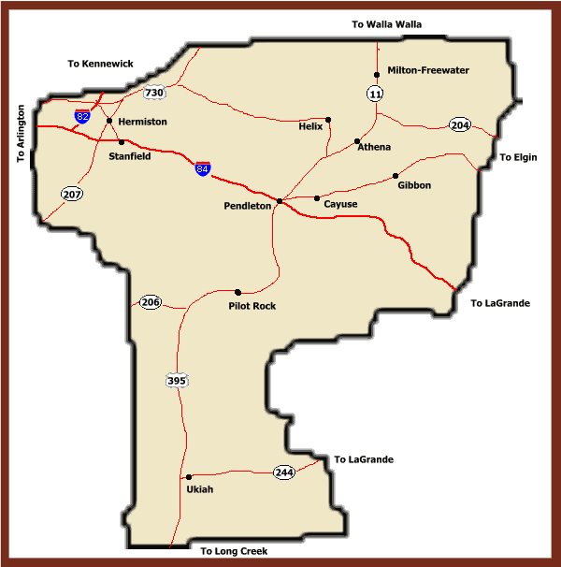
- the landowner offer

Appendix D
Enabling Legislation and Governance

The Umatilla County SWCD is defined by Oregon Revised Statutes as a political subdivision of state government. The District is not a state agency, rather it is classified as a municipal corporation, a form of local government that is required to follow five basic requirements under ORS 568 to remain legal and become eligible for funding from ODA. ORS 568.554 contains two requirements stating that, “Each conservation district shall submit to the ODA its proposed long-range plan and annual work plan for review and comment.” Next ORS 568.580 states that the Board of Directors shall call an annual meeting where they shall present an annual report and audit. Fifteen days before the annual meeting the Board shall post three public notices within the district or publish, on two consecutive weeks in the local paper, the details of the time and place of the annual meeting according to ORS 568.590. Finally, in accordance with ORS 568.610, the Directors shall provide full and accurate records of all proceedings and schedule an annual audit of accounts.

The Oregon Legislature passed the Soil Conservation District Law on August 5, 1939, which created a Soil Conservation Committee. This law authorized the committee to begin forming Soil Conservation Districts, which were changed to Soil and Water Conservation Districts in 1963. The primary statutes relating to the formation and governance of Oregon Soil and Water Conservation Districts are contained in ORS 568.210 through 568.890. A listing of these statutes follows in Appendix E, and a complete text is available in the Oregon Soil and Water Conservation District Law Book. The general powers and authorities of conservation districts in Oregon are described in ORS 568.550 and are detailed in Appendix F. Additionally, conservation districts are subject to the provisions of several other statutes and Oregon Administrative Rules (OARs) as outlined in Appendix G. The full text of statutes is available at http://www.leg.state.or.us and the full text of the administrative rules is available at http://www.sos.state.or.us/archives/rules.

All Oregon Soil and Water Conservation Districts are classified as special districts under ORS 198.010 through ORS 198.955. As special districts, conservation districts are eligible to become members of the Special Districts Association of Oregon. SDAO provides a variety of resources, consultation, insurance plans, and training opportunities to its members.

In addition to the powers and authorities previously described, ORS 568.730 authorizes districts “to go upon any lands within the district, after notifying the owner or operator, for the purpose of making surveys and to determine whether land-use regulations adopted under ORS 568.630 to 568.690 are being observed. Due precaution shall be taken at all times to prevent injury to growing crops or livestock.” While implementing agricultural water quality management program strategies, ORS 568.915 states “after a reasonable attempt to notify the landowner, the Department of Agriculture or a designee of the department may go upon any lands within the area subject to a water quality management plan for the purpose of determining: 1) those actions that may be required of a landowner under ORS 568.900 to 568.933 and, 2) whether the landowner is carrying out the required actions.”

Senate Bill 1010, passed by the Oregon Legislature in 1993, directs ODA to work with farmers and ranchers to develop area-wide water quality management plans for the state’s watersheds. SB1010 is the primary tool that the Oregon agricultural community is using to respond to the federal Clean Water Act, Coastal Zone Management Act, Endangered Species Act, Oregon Plan for Salmon and Watersheds, and other natural resource conservation mandates. Conservation districts are essential partners with ODA and private landowners in implementing SB1010’s Agricultural Water Quality Management Program. The Local Management Agency of SB1010 is Umatilla County SWCD in the Marion, Linn, and Clackamas watershed areas. Conservation districts provide assistance to landowners in evaluating their property and implementing conservation measures. Districts also help landowner’s access technical and financial resources through NRCS and other local, state, and federal agencies.

The Soil and Water Conservation Commission is an advisory body to ODA and consists of seven SWCC Directors, appointed by the Director of ODA. These directors are voting members who serve four-year terms and are limited to two consecutive terms. In addition to the voting directors, several agencies and organizations serve as advisors to the commission. The advisors include representatives of NRCS, Farm Service Agency, OSU Extension Service, Oregon Watershed Enhancement Board, and the OACD. The chair of the commission, by statute, also serves on the Oregon Board of Agriculture. The commission’s primary function is to coordinate the programs of ODA, NRCS, FSA, OSU Extension Service, OWEB, and OACD with the needs of Soil and Water Conservation Districts to carry out their statutory responsibilities effectively. The commission also serves as an advisor to the director of ODA on natural resource issues.
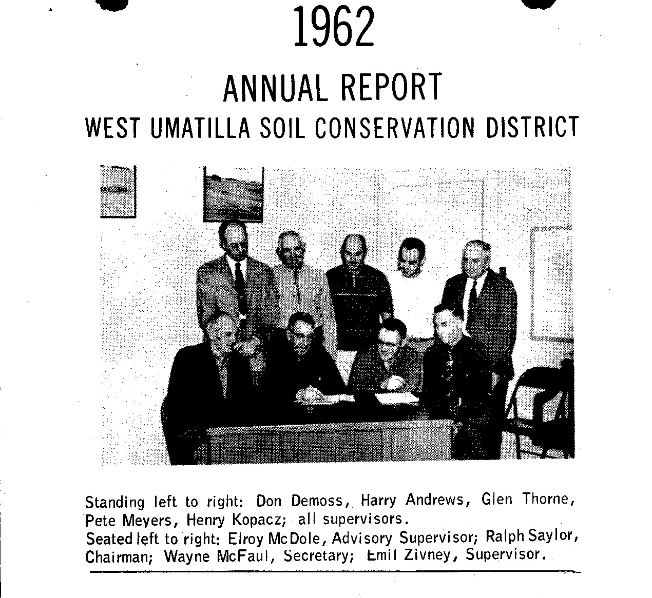

Appendix E
ORS, Statutes 568.210-568.890
568.210 Definitions for ORS 568.210 to 568.808 and 568.900 to 568.933
568.225 Policy
568.300 petition for formation of district; contents; consolidation of petitions
568.310 Notice of hearing; questions considered
568.320 Owner and interested parties have right to be heard; subsequent notice and hearings
568.330 Determination of need for district recorded; factors considered in determination; territory need not be contiguous
568.340 Determination of no need for district recorded; subsequent petitions may be filed
568.350 Referendum; purpose
568.360 Referendum ballot; contents
568.370 Eligible electors
568.380 Department to pay expenses and supervise hearings and referenda; informalities in referendum
568.390 Referendum results; majority required for creation of district
568.400 Appointment of first directors of district
568.410 Procedure for constituting district a public body
568.420 Certificate of organization by Secretary of State; boundaries of district
568.430 Petitions for inclusion or withdrawal of territory; form; eligible electors
568.440 District legally established; certificate as evidence
568.445 Petitions for inclusion of territory wholly within another district; approval or disapproval by directors and department
568.450 Procedure for consolidating districts
568.460 Referendum; eligible electors; majority required
568.470 Effect of consolidation on several districts
568.480 Petition and referendum for discontinuance of district
568.490 Directors to wind up affairs and dispose of property; application and certificate to Secretary of State
568.500 Certificate of dissolution; effect
568.510 Proceedings for discontinuance limited
568.515 Termination of inactive district’s existence
568.520 Petitions nominating directors; regular elections
568.530 nominees’ names placed on referendum ballot
568.540 Votes necessary to elect directors
568.542 Payment of expenses for director election from county funds
568.545 Procedure for selection of directors of consolidated districts; selection of officers
568.550 General powers of directors (See Appendix F)
568.552 Power of directors to manage and control water resources and projects; authority of Water Resources Commission
568.554 District to submit program and work plans for department review
568.555 Name of district may be changed
568.560 Number of directors; officers; election; terms; vacancies
568.565 Procedure for reducing number of directors
568.570 Majority constitutes a quorum
568.580 Annual meeting
568.590 Notice of annual meeting
568.600 Legal counsel; delegation of powers; assistance to department
568.610 Records; audits
568.620 Consultation with county or municipal representatives
568.630 Directors may formulate land-use regulations; public meetings
568.640 Referendum on land-use regulations; notice; form of regulations; proposed regulations available for inspection
568.650 Contents of referendum ballot; referendum governed by directors; landowner’s eligible to vote
568.660 Votes necessary for approval; effect of regulations when adopted
568.670 Landowner may petition for amendment or repeal; procedure; referenda limited
568.680 Scope of regulations; approval by department
568.690 Regulations to be uniform; copies to be available to landowners
568.700 Directors petition circuit court for enforcement of regulations; contents of petition
568.710 Hearing and decree; court may appoint referee; joinder of owner and occupant
568.720 Court retains jurisdiction until work completed; statement of expenses; judgment
568.730 Officials may enter private lands
568.740 Board of adjustment established for each district; membership; appointment; term; disqualification
568.750 Vacancies in board of adjustment; compensation of members; administrative expenses
568.760 Rules of board of adjustment; meetings
568.770 Petition for relief from regulations; hearing; procedure; board may order variance of regulations; appeal
568.780 Certain public agencies to be deemed owners
568.790 County funds for personnel and other uses; duties of county extension agent
568.801 Stream control and management projects; application; designation and implementation; rules
568.805 Special assessments; improvement bonds; remonstrance by landowners (Tax Levying Authority)
568.806 Ad valorem tax; budget; collection
568.807 Electors authorizing taxation; election date
568.808 Taxing district to file legal description and map

WIND EROSION CONTROL
568.810 Purpose of ORS 568.810 to 568.890; types of wind erosion
568.820 Designation of areas by county court upon petition; description of boundaries
568.830 Publication and posting of notices describing districts; when regulations are enforced
568.840 Election of advisory board; meetings; members; function

568.850 Wind erosion inspector; appointment; duties; appeal from decision; compensation; expenses
568.860 Inspector may enter lands in district; service of notice on owner or occupant
568.870 County court may authorize inspector to control erosion; expenses of control
568.880 Tax levy for wind erosion control
568.890 District may be dissolved; disposition of district funds; change of district boundaries

The complete text of these statutes is available in the Oregon Soil and Water Conservation District Law Book.

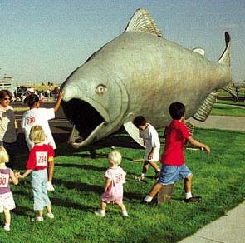
Salmon Walk “05”
Appendix F

ORS 568.550

The general powers and authorities of conservation districts in Oregon are described in ORS 568.550 as follows:

- To secure surveys and investigations and do research relating to:
- the character of soil erosion;
- the character of flood water and sediment damage;
- all phases of the conservation, development, utilization and disposal of water; and
- the preventive measures, control measures and improvements needed.
- To conduct demonstration projects on lands within the district upon obtaining the consent of the owner and occupier of such lands.
- To carry out preventive and control measures on lands within the district upon obtaining the consent of the owner and occupier of such lands.
- To enter into written agreements with and within the limits of appropriations duly made available to it by law, to furnish financial or other aid to any agency, governmental or otherwise, or any owner or occupier, or both of them, of and within the district, for the purpose of carrying on soil erosion control and prevention operations within the district.
- To obtain options upon and to acquire by purchase, exchange, lease, gift, grant, bequest or devise any property, real or personal or rights or interests therein; to maintain, administer and improve any properties acquired; to receive income from such property and to expend such income in carrying out the purposes and provisions of ORS 568.210 to 568.808 and 568.900 to 568.933; and to sell, lease or otherwise dispose of any of its property or interests therein in furtherance of the purposes of ORS 568.210 to 568.808 and 568.900 to 568.933.
- To borrow money and to mortgage personal property of the district as security therefore; provided, landowners are given opportunity to be heard at a public hearing in the district, notice of which shall be given according to rules described by the department.
- To make available, on such terms as it shall prescribe, to landowners or occupiers within the district, agricultural and engineering equipment, fertilizer, seeds and seedlings and other material or equipment.
- To construct, operate and maintain such structures as may be necessary or convenient for performance of any of the operations authorized in ORS 568.210 to 568.808 and 568.900 to 568.933.
- To develop comprehensive plans and specifications for the conservation of soil resources and for the continued control and prevention of soil erosion within the district, and to publish such plans, specifications, and information and bring them to the attention of owners and occupiers of lands within the district.
- To take over, by purchase, lease, or otherwise, and to administer, any soil conservation erosion control, or erosion prevention project, or combination thereof, located within its boundaries undertaken by the United States or any of its agencies, or by the state or any of its agencies.
- To manage, as agent of the United States of any of its agencies, or of the state or any of its agencies, any soil conservation, erosion control, or erosion prevention project, or combination thereof, within its boundaries.
- To act as agent for the United States or any of its agencies, in connection with the acquisition, construction, operation, or administration of any soil conservation erosion control, or erosion prevention project, or combination thereof, within its boundaries.
- To accept donations, gifts and contributions in money, services, materials, or otherwise from the United States or any of its agencies, or from this state or any of its agencies, and to use or expend such moneys, services, materials or other contributions in carrying out its operations.
- To sue or be sued in the name of the district; to have a seal, which shall be judicially noticed; to have perpetual succession unless terminated as provided by law; to make and execute contracts and other documents necessary or convenient to the exercise of its powers; to make, and from time to time amend and appeal, rules not inconsistent with ORS 568.210 to 568.808 and 568.900 to 568.933 to carry into effect its purposes and powers.
- As a condition to the extending of benefits under ORS 568.210 to 568.808 and 568.900 to 568.933 to, or the performance of work upon, any lands not owned or controlled by this state or any agencies, the directors may require contributions in money, service, materials or otherwise to operations conferring such benefits, and may require landowners and occupiers to enter into and perform such agreements or covenants as will tend to prevent or control erosion thereon.
- To purchase liability insurance or indemnity insurance, in such amounts and containing such terms and conditions as they may deem necessary, for the protection of directors, officers and employees in the performances of their official duties. The premiums for such insurance shall be paid out of moneys available for expenditures by the district.

Appendix G

Related Statutes and Administrative Rules

STATUTE | DESCRIPTION
Americans with Disabilities Act of 1990 | Hiring Persons With Disabilities- Federal
OAR 137-30-000 through 137-35-080 | Oregon Public Contraction Law
Oregon Constitution Article XV, Section 3 | Oath of Office
ORS 44.320 | Oath of Office
ORS 190.003 through 190.110 | Intergovernmental Cooperation
ORS 192.001 | Public Records Policy
ORS 192.005 through 192.190 | Custody and Maintenance of Records
ORS 192.310 | Records and Reports
ORS 192.410 | Inspection of Public Records
ORS 192.610 through 192.710 | Public Meetings
ORS 198.010 through 198.955 | Special Districts
ORS 198.330 through 198.365 | Dissolution of Inactive Districts
ORS 198.410 through 198.440 | Recall (of district directors)
ORS 244.010 through 244.400 | Conflict of Interest
ORS 247.035 | Residency
ORS 292.210 through 292.250 | Subsistence and Mileage allowances for Travel by State Officers and Employees
ORS 294.305 through 294.565 | Local Budget- Required of district with a tax levy
ORS 297.005 through 297.712 | Contracting
ORS 297.210 through 297.230 | Auditing Accounts of State and State-Aided Institutions and Agencies Laws
ORS 297.405 through 297.485 | Municipal Audits
ORS 542.750 | Watershed Protection and Flood Protection
ORS 561.395 | Soil and Water conservation Commission
ORS 561.400 | Natural Resources Division (ODA)
ORS 568.900 through 568.933 | Agricultural Water Quality Management
ORS 659.010 through 659.990 | Civil Rights, Unlawful Employment Practices
ORS 659.405 | Civil Rights of Disabled Persons
Title VII Civil Rights Act of 1964 | Equal Opportunity Employment/Sexual Harassment/Discrimination- Federal

