Umatilla County Soil and Water

Conservation District

5 Year Business Plan

2015-2020

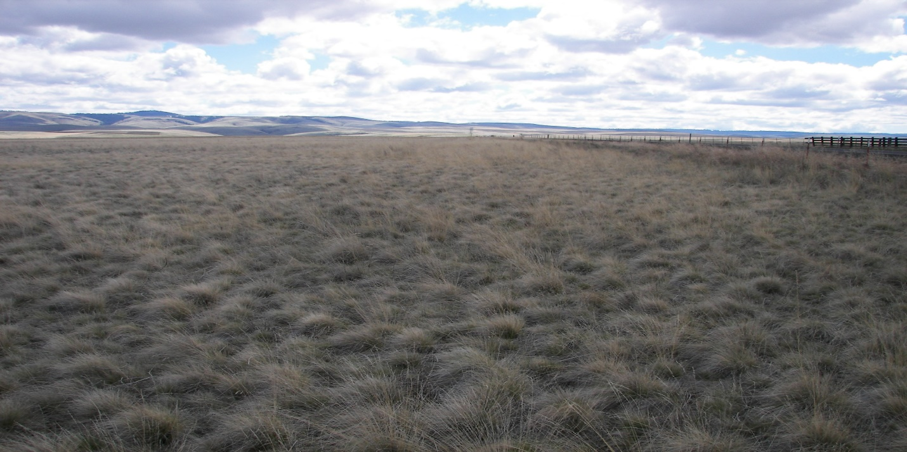

Approved June 17th, 2015 Board Meeting

Umatilla County SWCD

Address: 1 SW Nye Ave. Suite 130

Phone: 541-276-8131

FAX: 1(855) 824-6184

Email: [umcoswcd@eotnet.net](mailto:umcoswcd@eotnet.net)

Website: www.umatillacountyswcd.com

**Board of Directors**

Chair — Berk Davis — Zone 2 — Expire 2018

Vice Chair – Colin Hemphill – Zone 5 — Expire 2018

Secretary/Treasurer – Tom Straughan – Zone 4 — Expire 2016

Aaron Madison — Zone 1 — Expire 2016

Tim Spratling – At Large – Expire 2016

Gus Wahner – At Large – Expire 2016

Vacant – Zone 3 – Expire 2015

***Associate Directors***

Chuck Hemphill

Dinah Hemphill

Ray Reser

Robert Rosselle

Frank Woody

***Monthly Meetings***

Board Meetings are held third Wednesday of every month at 6:00 PM in the USDA Conference Room. The public is invited.

Table of Contents

Executive Summary 5-6

Geography and Agriculture 7

Structure and Governance 7-9

Enabling and Governing Legislation

History

Leadership

Associate Directors

Mission, Values, and Guiding Principles 10

Mission

Vision

Values (and/or Guiding Principles)

Roles and Responsibilities 10-12

Local Level

Regional Level

State Level

National Level

Revenue to the County Economy

Goals and Objectives 12-14

Natural Resource Concerns and Outcomes 14-15

Resource Concern #1

Resource Concern #2

Resource Concern #3

Resource Concern #4

Resource Concern #5

District Programs 15-16

Program #1

Program #2

District Capacity, Needs, and Strategies 16-18

Capacity Needs Strategies Appendixes

Appendix A: General Powers of Soil and Water Conservation District Directors 18-19

Appendix B: Statues and Administrative Rules 20-22

Appendix C: Acronyms used in this Business Plan 23 Appendix D: Current Fiscal Year Budget 24- 26

Map of District

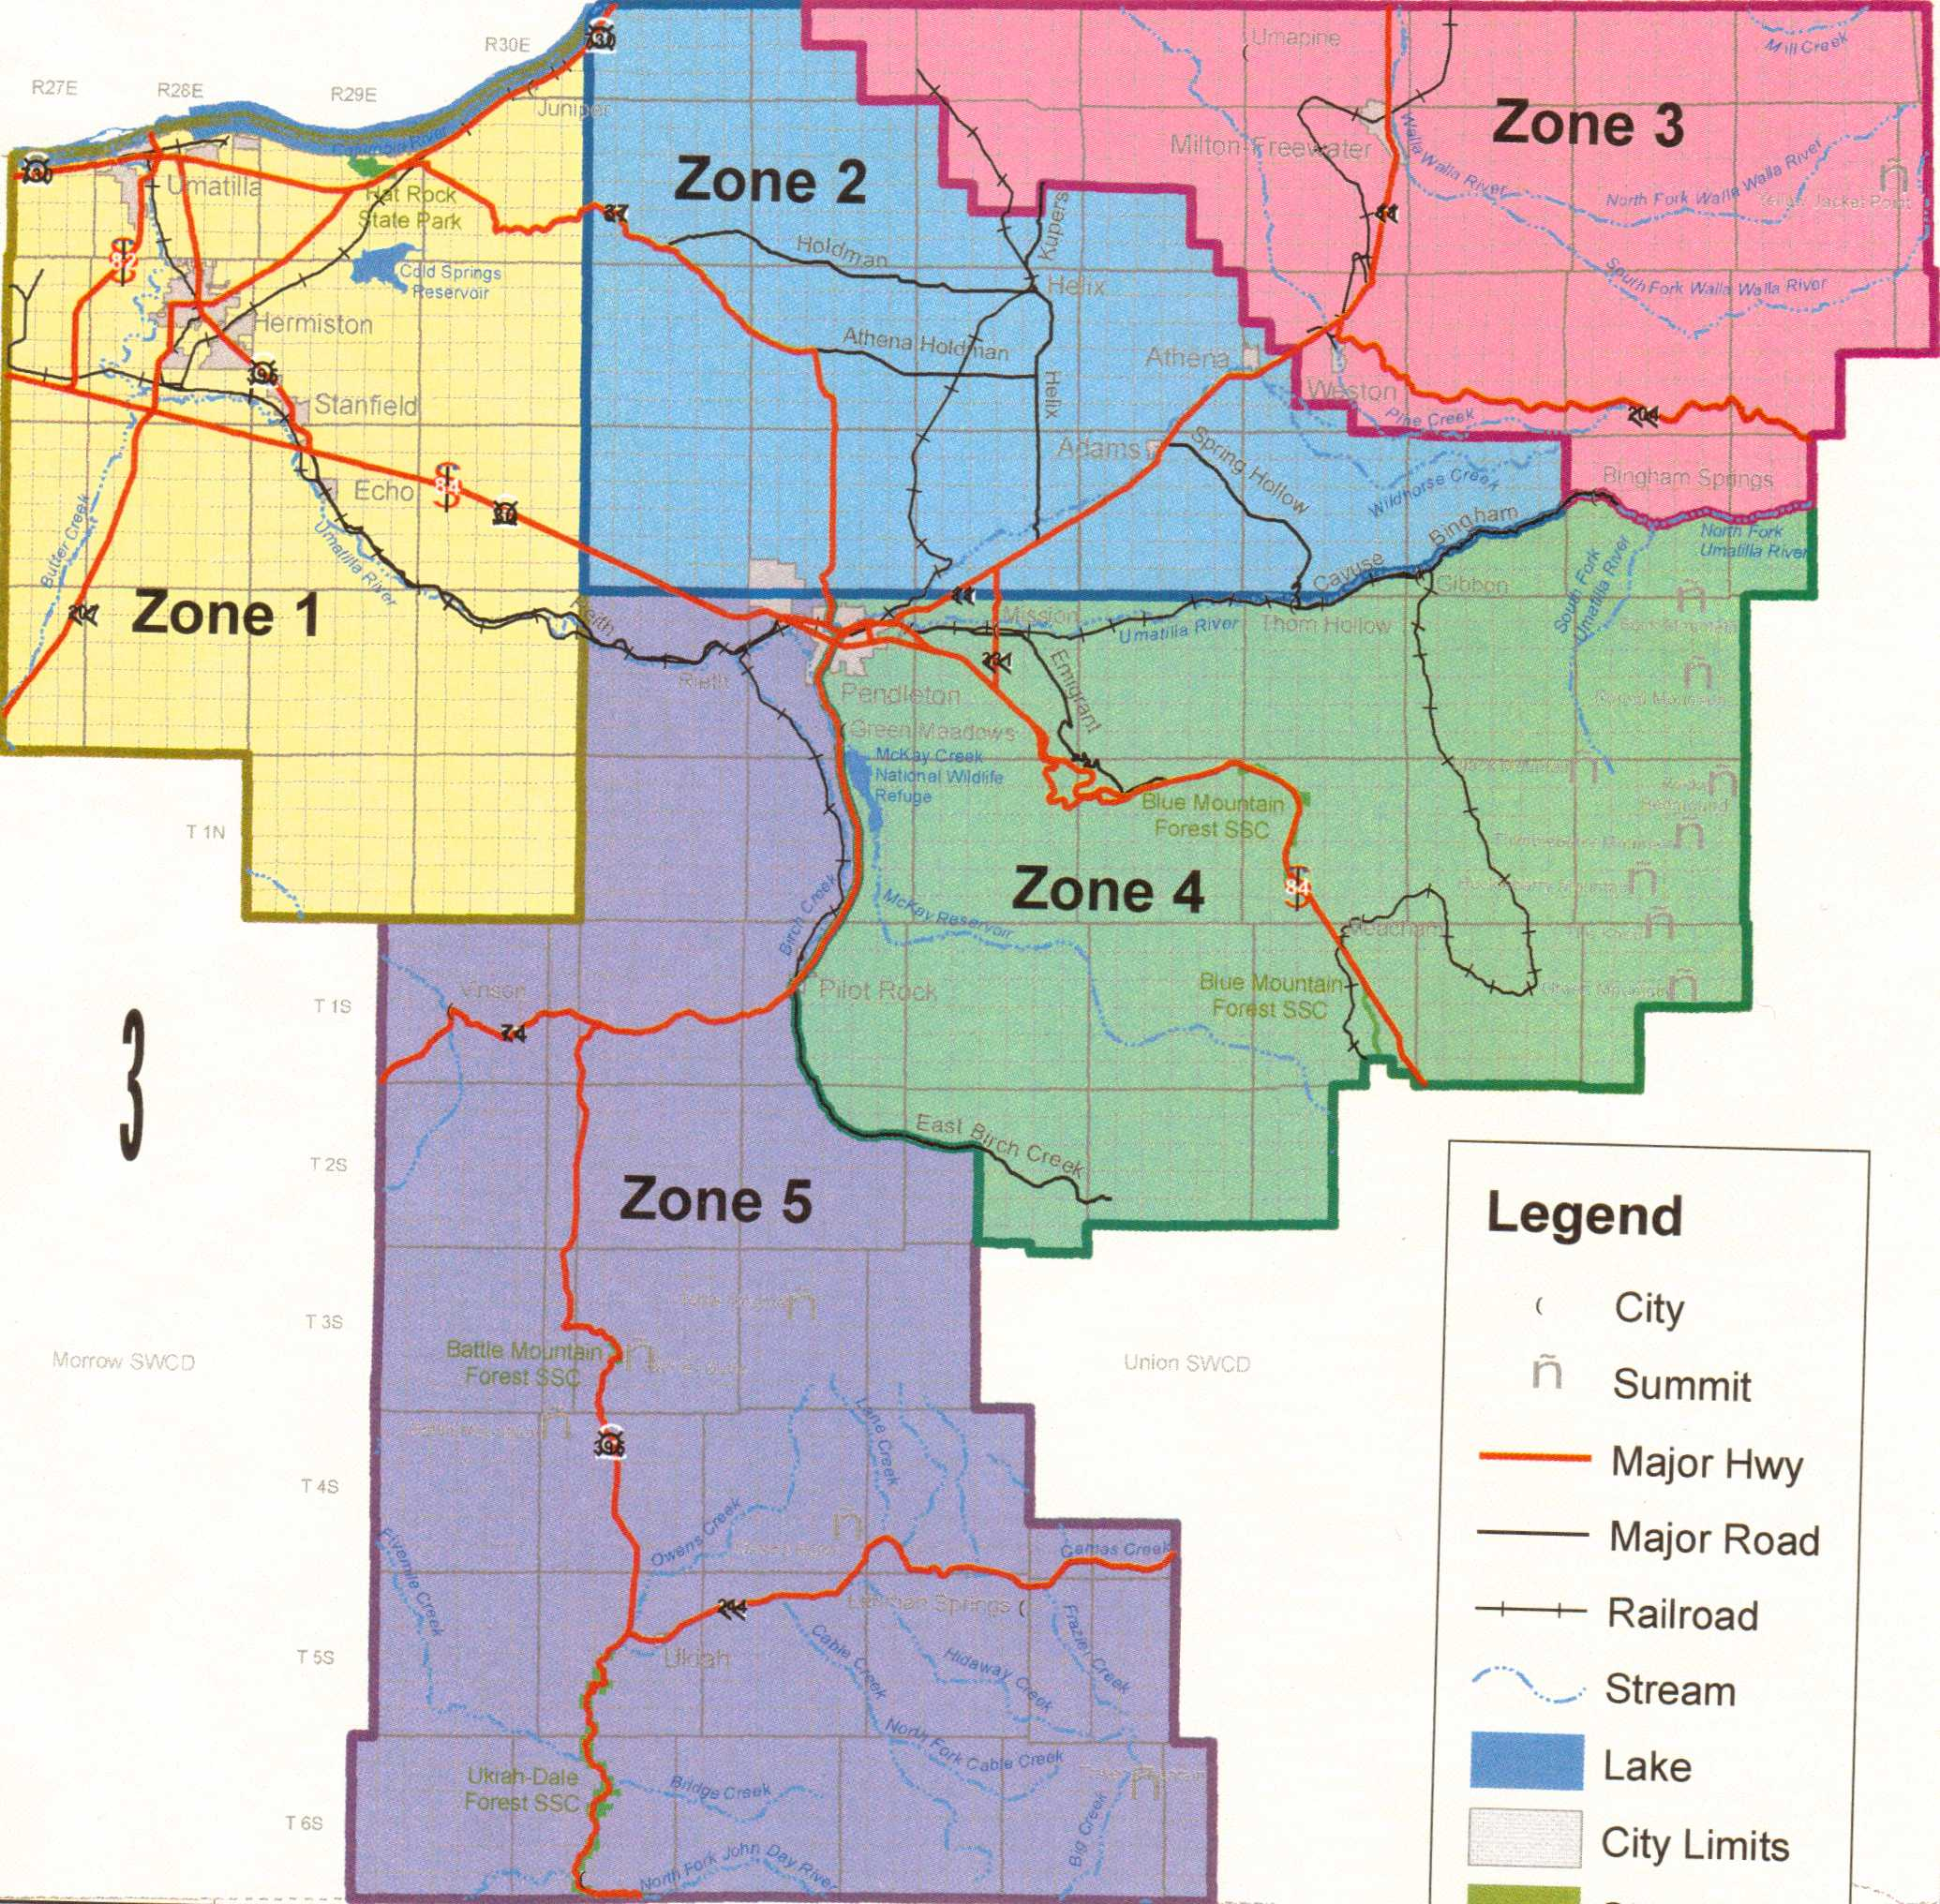

***Executive Summary***

This five year Business Plan (2015-2020) details the Umatilla County Soil and Water Conservation District services, activities, resources, staffing, and finances currently available and planned to carry out its mission. The Business Plan also contains general information about the District and Umatilla County and guides the development of the District’s annual work plans and budgets.

*Public Participation*

This Plan was prepared with input from: District Board members, District Staff, Oregon Department of Agriculture staff, and USDA Natural Resource Conservation service staff.

*Audience*

This plan is intended for Umatilla County residents, Umatilla County government officials, funding sources, legislators, and partner agencies.

***Staff***

*District Manager-* is responsible for overall management of the Conservation District, supervision of District employees, and providing technical assistance to District clients. The District Manager assists the Board of Directors with coordination, management, and administration of conservation programs throughout the Umatilla County SWCD. The District Manager ensures that all District functions are managed and services are provided in accordance with applicable local, state, and federal laws, regulations, and policies.

*Current-Tom Demianew*

-Bachelor of Science degree from Oregon State University in Rangeland Resource Management

-18 years’ experience in developing agricultural business opportunities

-7 years’ as Confederated Tribes of the Umatilla Indian Reservation program manager for Range and Pasture lands program

-7 years’ as Soil Conservation Planner for the United States Department of Agriculture-Natural Resource Conservation Service

-2 years’ as Area Manager for the United States Department of Agriculture-Rural Development

-Training and experience in facilitation, community organizing and training, conservation planning, and leadership development

-Hired as District Manager January 1, 2012

*Education Outreach & Programs Coordinator-* is responsible for coordinating and executing outreach activities for Umatilla SWCD. Develop and enhance programs that will influence practices leading to increased conservation efforts and education in Umatilla County. The Conservation Outreach Coordinator will support countywide SWCD outreach efforts in conjunction with conservation events and partner events to provide conservation education.

*Current-Shanna Hamilton*

-Bachelor of Science in Agriculture Education from University of Idaho & Masters of Agriculture Sciences from Colorado State University

- 2 years’ as marketing consultant for cattle feed company

-3 years’ as Extension Educator for University of Idaho

-Experience in developing, organizing and evaluating workshops, field days, and educational outreach events.

-Grant writing, website and social media design

-Hired March 2013

*Administrative Assistant-performs duties as requested by District Manager, aids in Board of Director informational packets for meetings and fills in where appropriate.*

*Current-Kim Cash*

-Bachelor of Science in Human Service and Psychology

-10 years as a technical support agent/account manager for a technical support agency

-2 years as a technologies supervisor at Cayuse Technology

-Experience in managing multiple projects, working with students as a teaching assistant and through 4H programs

-Hired October 2013

- ***Board of Directors***

Zone 1 – Hermiston/Stanfield area: Aaron Madison

-Zone 2 – Helix/Adams area: Berk Davis, Chairman

-Zone 3 – Milton Free-water/Weston/Tollgate area: Vacant

-Zone 4 – Reith/Ukiah area: Tom Straughan, Secretary/Treasurer

- Zone 5 – Pilot Rock/Ukiah area: Colin Hemphill, Vice-Chairman

At Large

Gus Wahner, Stanfield

Tim Spratling, Helix

***Umatilla County History, Topography, and Land Uses***

Umatilla County was created on September 27, 1862, out of a portion of Wasco County. Umatilla is an Indian term meaning "rippling water" or "water rippling over sand" and has provided the name both for the county and its major river. Adjustments were made to the

County’s boundaries following the creation of Grant, Morrow, Union, and Wallowa Counties. The county contains 3,231 square miles and is bounded by the Columbia River on the north, Morrow County on the west, Grant County on the south, and Union and

Wallowa Counties on the east.

The legislative act that created Umatilla County designated Marshall Station as the temporary county seat. Umatilla City was chosen the county seat in an 1865 election. Population shifted to the north and east parts of the county due to the opening of the Pendleton area to wheat production. A subsequent election in 1868 resulted in the selection of Pendleton as the new county seat, supplanting both Marshall Station and Umatilla City.

The first courthouse was completed in 1866 in Umatilla City. The next courthouse, and the first built in Pendleton, was a wooden, two-story structure completed in 1869. In 1889 a three-story brick courthouse and jail was erected. A fourth courthouse was built on the site of the old courthouse in 1956 and is still in use today.

The government of Umatilla County consisted originally of a county judge, two county commissioners, clerk, and sheriff. The offices of treasurer, assessor, coroner, and superintendent of schools were added a short time after formation of the county. The county judge position was abolished and a third commissioner was added in 1975.

Umatilla County is represented by Senate District 29; and Representative Districts 57 and 58; and the Second Congressional District. The first census of the Umatilla County in 1870 counted 2,916 inhabitants. The population has increased steadily with a 2010 census figure of 75,899.

The Umatilla Indian Reservation was established by the Treaty of Walla Walla in 1855. It became an 800 square mile home for the Umatilla, Walla Walla, and Cayuse tribes and is located immediately southeast of Pendleton. The Umatilla Confederated Tribes have approximately 3,000 enrolled members.

Lewis and Clark and pioneers traveling the Oregon Trail passed through the area. The gold rush of 1862 brought miners and stock raisers to the mountains and grasslands of Umatilla County. The county expanded after the coming of the railroad in 1881 and the area was open to the development of dry land wheat farming. The fertile land of Umatilla County gives a strongly agricultural base to the county's economy. Fruit, grain, timber, cattle, and sheep are important agricultural products. Recreation, primarily in the Blue Mountains, and tourism, most notably for the annual Pendleton Round-Up rodeo, are also important to the local economy.

**Structure and Governance of District**

Enabling and Governing Legislation

The Umatilla County SWCD is one of 45 conservation districts in Oregon. Conservation districts are defined in Oregon law as political subdivisions of state government. Umatilla County SWCD is not a state agency. Rather it is classified as a municipal corporation, a form of local government, which is required to follow many of the same laws that govern state agencies and special districts. It is specifically governed by ORS 568.210 to 568.890 and ORS 568.900 to 568.933. See Appendix A for the specific powers and authorities granted to districts. Appendix B lists other Statutes and administrative rules to which Umatilla County SWCD is subject.

The Oregon Revised Statures (ORS) that established and govern Oregon’s SWCDs (except the federal tribal Tiicham Conservation District) was significantly revised by the 2009 Legislative Assembly under House Bill 2082. The origin of the House Bill was a collaborative effort among the Oregon Association of Conservation Districts, member Conservation Districts, and the Oregon Department of Agriculture. It was designed to address the evolving challenges and opportunities presented to today’s SWCDs that were not envisioned when the Statue originated, and to eliminate antiquated provisions in the previous editions.

In addition to the general purpose of SWCDs under ORS 568.225 in the previous editions, the following was added: “promote collaborative conservation efforts to protect and enhance healthy watershed functions, assist in the development of renewable energy and energy efficiency resources”.

District History

The Umatilla County SWCD was established in 1974 to direct agricultural producers to technical assistance resources, such as our partners the NRCS. Since 1974, NRCS and the Umatilla County SWCD have partnered to plan and implement conservation practices on private lands in the basin.

The Umatilla County SWCD was originally three separate districts. They were West Umatilla Soil Conservation District (established March 28, 1946), Southern Umatilla Conservation District (established 1953), and East Umatilla Soil Conservation District (1960). Each of these Soil Conservation Districts (SCD) were organized for a little different reason. West Umatilla SCD was organized around irrigated lands near Irrigon and Hermiston with a primary purpose to stabilize wind erosion problems. Southern Umatilla SCD was organized around the community of Pilot Rock and eventually expanded to include all of the southern area of Umatilla County. East Umatilla County SCD was formed around Milton-Freewater extending into the rich agricultural lands toward Athena, Oregon.

Directors

A board of seven directors governs the District. Directors are elected by the electorate of Umatilla County at the November General Election, which is held during even-numbered years. Director positions are elected in staggered terms to provide continuity on the board and maintain consistent operations. The Umatilla SWCD Board may appoint a person to fill a board vacancy between elections for the duration of that position’s term. Five of the seven positions are classified as zone positions and must meet the zone requirements and terms of office as specified in ORS 568.560 as follows: “Zone directors must own or manage 10 or more acres of land in the district, be involved in the active management of that property, reside within the boundaries of the district, and be a registered voter.”

An individual may serve as a zone director in lieu of land ownership or management requirements if the individual resides within the zone that is represented, has served at least one year as a Umatilla County SWCD Director or Associate Director and has a conservation plan approved by the Umatilla County SWCD Board. The other two positions are at-large positions. To qualify for an at-large position, a person must reside in Umatilla County and be a registered voter. No land ownership or management requirements are needed for an at-large position, which is also governed by ORS 568.560

An **individual** **director** has power only when acting as a part of the Umatilla County SWCD Board. Individual board members may be delegated authority or power to act on behalf of the Board in specific, limited tasks. This authority or power is granted through board action (resolution, motion, policy, etc.) and must be recorded in the meeting minutes.

The Umatilla County SWCD Board works cooperatively as a unit to plan and oversee implementing Umatilla County SWCD programs. As a representative of the Umatilla County SWCD Board, opinions expressed publicly by individual board members should be consistent with established board policy, not the individual’s personal agenda or opinions. (See Appendix A)

ORS 568.560 requires all SWCD’s to select a Chair and Secretary from among its directors. Umatilla County SWCD may elect other officers as desired.

The **Chair** is granted the responsibility to represent Umatilla County SWCD with other districts, agencies, associations, partners, organizations, legislators, and property owners consistent with the policies, plans, and interests of Umatilla County SWCD. The Chair will also conduct regular and special meetings of the Board.

A **Vice-Chair** has been given the authority to act as the Chair in case of the absence or unavailability of the Chair.

The **Secretary/Treasurer** is the custodian of all Umatilla County SWCD records, minutes, contracts, and other official documents.

**Committees** are and effective way for Umatilla County SWCD to plan and implement Umatilla County SWCD functions. They can be comprised of board members, associate directors, and Umatilla County SWCD advisors, representatives of cooperating agencies and associations, or interested citizens. Currently the Umatilla County SWCD has two standing committees. These committees are the Budget committee and Personnel Committee.

The Umatilla County SWCD don not have various ad hoc committees, which are charged with specific tasks over a specific time period. Ad hoc committees are then disbanded after the assigned task and or time frame is completed.

Associate Directors

Associate Directors are non-voting members of the District Board. They are appointed by the Directors to serve as advisors and representatives. Associate directorship offers a way to educate potential directors, broaden community input to the District, and expand District programs.

**Mission, Values, and Guiding Principles**

Mission

To conserve, protect and develop soil, water and other natural resources for the economic and environmental benefit of the residents of Umatilla

Vision

The vision for Umatilla County Soil and Water Conservation District includes transition to broader service, broader use of technology, and networking with Natural Resource Agencies to develop a center that offers student education, personal development, improved job opportunities and economic opportunities and landowner easy access to a variety of assistance for Natural resource protection and conservation. With these new linkages and collaborations, to become an interconnected, networked community model to be duplicated with adaptations other parts of the state, while maintaining the goals of our mission statement.

Values (Guiding Principles)

The Umatilla County Soil and Water Conservation District prides itself on providing the Best customer service one could offer. We are a non-regulatory, non-judging organization that is good at listening to all parties and giving sounding advice to the landowners of Umatilla County.

**Roles and Responsibilities**

The Umatilla County SWCD works with agencies and individuals as partners in our efforts to achieve our vision. Various memorandums of agreement and/or understanding, working agreements, intergovernmental agreements and informal arrangements, formalize the partnerships. The agreements outline the responsibilities of each partner and identify the types of assistance, resources, and support each will provide to accomplish common conservation goals.

Local Level

*Landowners, Producers, General Public*

The General Public utilizes the Umatilla County SWCD as its primary point of contact for all District programs as well as those of the Oregon Department of Agriculture and the USDA’s Natural Resource Conservation Service. Landowners and agricultural producers can avail of technical assistance with natural resource concerns and assistance in securing grant or loan funding for an array of natural resource conservation projects.

*Umatilla County Soil and Water District*

The District assists the general public with conservation planning, technical and financial assistance, farm bill program opportunities, and answers to conservation-related questions.

The District provides sponsorship to grant programs, educational opportunities to youth and adults, and job-related skill development for producers and the general public.

*Oregon State University Extension Service*

The District maintains a working relationship with the Umatilla County office of Oregon State University Extension Service to provide an outlet for new and upcoming agricultural topics. The District also assists with the advisory network within the extension service discussing upcoming topics and concerns in the extension service in such things as programs and local staffing.

*County Government*

The Districts is a primary point of contact to local county government with Natural Resource issues in the County. The District Annually meets with the local Governing board to discuss projects that are occurring within the local conservation district and to look at future natural resource issues coming in the future.

Regional Level

*USDA Natural Resource Conservation Service (NRCS)*

The District maintains a Cooperative Working Agreement with the NRCS to provide office space and equipment and assistance with conservation planning and conservation practice implementation activities in Umatilla County. The District also from time to time enters into Contribution Agreements with NRCS to produce complete conservation plans. The NRCS provides technical assistance to the District and directly to county landowners and producers. The District is served through the NRCS office in the city of Pendleton, Oregon.

*Local Advisory Committee*

The Local Advisory Committee is made up of landowners, agricultural producers, and an environmental representative whose charge is to develop and implement the Agricultural Water Quality Management Area Plan. The plan is used to direct the District staff to focus on water quality issues within Umatilla County and how to address these issues under the National and State Water Quality Laws.

State Level

*Oregon Department of Agriculture (ODA)*

The Oregon Department of Agriculture Natural Resources Division provides administrative oversight and partial administrative and technical support funding.

*OWEB, DEQ, and other State Agencies*

The Oregon Watershed Enhancement Board (OWEB), the Department of Environmental Quality (DEQ), and other agencies provide financial resources through grants for habitat restoration and water quality improvement projects.

*Oregon Association of Conservation Districts*

The OACD provides technical and administrative support to the District. It is also the main conservation district advocacy organization to the Oregon State legislature and agencies.

National Level

The national NRCS offices provide the funding for the work agreements and contracts with the District.

Revenue to the County Economy

Through the relationships with local, state and national conservation programs the District estimates that it adds approximately $300,000.00 amount of dollars into the local economy yearly. The revenues come through Programs such as Oregon Watershed Enhancement Board Grants, Department of Environmental Quality Grants, Oregon Department of Agriculture Water Quality Program funding, and United States Department of Agriculture Farm Programs. (Appendix D)

Over the past 5 years the Umatilla County Soil and Water Conservation District has brought in over 1.8 million dollars into the local economy. A University of Oregon study states that for every 1 million dollars will create and sustain approximately 18 jobs. It also is turned over 2 times with over 80% of the dollars staying local due to the distance from distributers and cities. If using the factor of 2 the Umatilla County Soil and Water Conservation District in the past five years has generated over 3.6 million dollars in the local economy.

**Goals and Objectives**

*Goal #1*: Sustain and enhance current programs that provide technical and financial assistance to property owners, partners, operators, and residents of Umatilla County.

***Objectives***

1. Maintain Current relationships with partners such as Oregon Department of Agriculture, United States Department of Agriculture, Oregon Watershed Enhancement Board, Department of Environmental Quality, and Umatilla County.

2. Expand our opportunities with new partners such as Cooperatives, Oregon State University, Blue Mountain Community College, Northeast Oregon Water Association, and Pacific Northwest Direct Seed Association.

3. Maintain current level of service of existing programs and adapt them to current needs. Current Programs include:

* Water Quality Program (LUB-GWMA)
* Watershed Restoration Program
* Invasive Species Control Program
* Salmon Safe Programming
* Soil Health Programming
* Education and Engagement Activities

4. Expand current existing program capacity as opportunities become available to assist landowners with conservation and restoration efforts to improve land use in Umatilla County

*Goal #2*: Expand technical and outreach capacity to include new programs and services to property owners, partners, operators, and residents.

***Objectives***

1. Increase public awareness of the Soil and Water Conservation District through outreach and engagement activities. Continue to develop an outreach program through media sources and meetings.

Examples of opportunities:

* Blue Mountain Horticulture Society
* Umatilla County Cattleman
* Oregon Wheat Growers League
* Oregon Pea Growers Association
* Northeast Oregon Water Association
* Umatilla Basin Watershed Council
* Chamber of Commerce (Pendleton, Hermiston, Milton-Freewater)
* Youth Organizations (Future Farmers of America, OSU 4-H, Children Museums, Art Councils
* Umatilla County Commissioners and City Councils
* Umatilla County School Districts

1. Expand programming efforts to web-based workshops, social media outlets, and innovative approaches to gain participation

* Promote SWCD educational and engagement program efforts; soil health, watershed health, air quality, energy efficiency, and BMP’s on SWCD social media outlets, radio, and website
* Promote USDA programming efforts on SWCD social media outlets

*Goal #3***:** Continue to administer Umatilla SWCD operations to be legally accountable and fiscally responsible, to uphold the highest function of district operations.

***Objectives***

* Implement the Board-approved Umatilla SWCD planning process
* Produce and maintain the annual work plan
* Develop and approve the Umatilla SWCD annual operating budget
* Complete financial audit per Oregon Revised Statute (ORS) 568, Section 297.425
* Review the Business Plan and update as necessary
* Conduct monthly staff, committee, and board meetings
* Provide evaluations, orientation, development, and training for staff
* Develop needed administrative policies and processes
* Recruit Board members as needed
* Hold an Annual Meeting
* Perform personnel, fiscal, and contract management

***Goal #4:*** Maintain a working relationships with agricultural organizations, watershed councils, cities, county, state, and federal entities while building new partnerships as available and accessible.

***Objectives***

1. Work closely with USDA programs and continue to collaborate on LUB-GWMA tasks and issues while investigating new partnering opportunities.
2. Collaborate with area councils and districts on developing programs that can be transparent

**Natural Resource Concerns and Outcomes**

A natural resource concern is a condition that does not meet agreed to or established criteria for a quality, sustainable resource. The resource concerns described below are intended to give a picture of the natural resource problems in Umatilla County and why they are important.

The top five Resource concerns in Umatilla County are:

*1. Water Quality*

*2. Soil Health*

*3. Watershed Health*

*4. Energy*

*5. Water Quantity*

Resource Concern #1 Water Quality

Description: Work with Oregon Department of Agriculture (ODA) on water quality and aid in developing plans to prevent and control water pollution from agricultural activities and soil erosion on rural lands. Help ensuring farmers and ranchers achieve water quality standards and meet the agricultural pollutant load allocations assigned by the Department of Environmental Quality (DEQ) in their Total Maximum Daily Loads (TMDLs).

Intended outcomes: Decrease sediment in local streams and rivers coming off surface runoff

Reduce temperatures through conservation practices

Reduce nutrients in groundwater supplies in Umatilla County

Resource Concern #2 Soil Health

Description: Working with local agencies to better the soil health in Umatilla County by using more biological process and conservation practices.

Intended Outcomes: Increase in Organic Matter

Decrease in Sediment Runoff

Increase in Economic Stability

Improve Air Quality

Resource Concern #3 Watershed Health

Description: Promote ecologically sound management practices in the uplands incorporating weed control, increasing water storage capabilities, and developing sustainable forage and forestry supplies.

Intended outcomes: Decreased Noxious Weeds

Healthier Forests

Longer runoff and higher quality spring and streams

Resource Concern #4 Energy

Description: Promote sound energy conservation tools.

Intended outcomes: Reduction in the energy draw demanded by producers in Umatilla County

Resource Concern #5 Water Quantity

Description: Look for water storage opportunities in Umatilla County

Intended Outcomes: Longer surface water opportunities in the region

Increased knowledge of water conservation techniques

**District Programs**

Program #1 *Water Quality, Quantity and Irrigation Efficiency and Improvement*

Program overview: Continue to work through Biennial Reviews and Long Range Planning on water issues in Umatilla County through Oregon Department of Agriculture and Lower Umatilla Basin Ground water Management Area (LUB-GWMA). Research opportunities with water conservation programs in the irrigated areas of Umatilla County.

Goal: Attend meetings as a representation of landowners in Umatilla County

Program #2 *Education and Engagement Program*

Program Overview: Umatilla County SWCD provides educational and hands-on opportunities to local communities dealing with land resource concerns in Umatilla County. Youth and adult programs as well as social media and website interactions.

Goal: Continue to develop a long term relationship with partners of Watershed Field days, Umatilla County Historical Society, and Local School Districts

Program #3 *Restoration and Watershed Health*

Program Overview: Continue to participate on the local DEQ TMDL (Total Maximum Daily Loads) technical team, delivering the water quality parameters establish by the Oregon Department of Agriculture. Research opportunities to provide assistance for conservation restoration on potential projects.

Goal: Continue to provide input and guidance to local restoration teams, water users, and environmental groups working with local producers and production interest groups.

**District Needs**

*List what you need/would like to have to improve capacity and delivery of services for you district.*

Staff: Conservation Planner

Part-time Administration Staff

Board of Directors: Milton-Freewater/Weston/Tollgate District Board Member

More funding available to send District Board members for trainings

Volunteers: Retirees

Associate Directors

Legal Assistance/Tax Base Knowledge

High School/CC Intern Program

Facilities and Equipment: Tablets for District Board Member Meetings

District Owned Vehicle

Partnerships: Umatilla Basin Watershed Council

Northeast Oregon Water Association

Irrigation Districts

Education Institutions and Education Service Districts

Funding: USDA Farm Bill Program Assistance

Umatilla County

Tax Base

Food and Farm Cooperatives

**District Strategies**

*List strategies to reach your needs.*

Staff: Consistent funding from USDA to ensure planner is meeting USDA Requirements to be a certified planner. This leads to increase time administering programs District is serving.

Board of Directors: More outreach in the Milton-Freewater area with producers who know about Umatilla County Soil and Water Conservation District goals

Volunteers: Continue to seek retired USDA workers

Facilities and Equipment: Continue to seek funding that cover the costs of District owned vehicles and capital expenditures

Partnerships: Continue to attend local meeting and outreach events dealing with goals and mission of the Umatilla County Soil and Water Conservation District

Funding: Research local Tax Base

Appendix A. General Powers of Soil and Water Conservation District Directors

Directors “Director” is the title given to a person who is elected or appointed to serve on a conservation district board. In some states, directors are called supervisors or district officials. In Oregon, conservation district directors are elected in the November General Election held in even numbered years. Directors serve four-year terms. Director terms are staggered so that all positions are not typically elected simultaneously. Staggered terms help provide continuity on the board and maintain operational consistency. A conservation district board may appoint a person to fill a vacant director position between elections. Roles and Responsibilities of Directors and Boards ORS 568.550 outlines the general statutory powers granted to conservation district boards . Individual directors do not have individual powers and authorities under statute, unless granted by the conservation district board. Individual directors may be given authority or power to act on behalf of the board for specific limited tasks. This authority or power is granted through board action (resolution, motion, policy) and must be recorded in the conservation district board meeting minutes.

Conservation district boards may choose to limit or grant authorities to individual directors relating to different actions, such as:

• Staff supervision.

• Obligating conservation district funds.

• Serving as a conservation district spokesperson for public presentations, media.

• Managing projects.

• Obligating or committing conservation district staff time or other conservation district resources.

• Signing documents.

Effective boards work cooperatively as a unit to plan and oversee the implementation of their conservation district’s programs. As a representative of the conservation district board, opinions expressed publicly by individual directors should be consistent with established board policy, regardless of the individual's personal agenda or opinions. Director Position Descriptions and Policy Although conservation district directors do not have individual powers and authorities under statute, unless granted by the conservation district board, it is in the best interest of the conservation district to identify the duties and responsibilities expected of individual directors. This can be accomplished by establishing conservation district director position descriptions or conservation district policy. Some customary duties and responsibilities of individual directors include:

• Attend and actively participate in all board meetings.

• Come to meetings prepared.

• Carry out committee responsibilities.

• Stay abreast of local conservation issues.

• Attend area and state meetings of the various state associations and other conservation partners.

• Participate in training opportunities.

• Promote the conservation district’s work to local landowners.

• Promote the conservation district’s work to its constituency.

• Promote the conservation district’s work to agencies and organizations.

• Promote the conservation district’s work to legislators and other decision makers regarding the conservation district’s funding. Conservation District Board Responsibilities In order to effectively exercise the powers and authorities as stated in ORS 568, conservation district boards should:

• Identify local conservation needs, programs, and services.

• Keep its conservation district's mission ("reason for being") in focus.

• Work effectively with conservation district staff, cooperating agencies, and partners.

• Implement conservation district programs effectively.

• Be knowledgeable about laws that govern board operations, such as budget, audit, public meetings, and contracting.

• Develop and implement a long-range plan and an annual work plan.

• Report to the public on conservation district programs and accomplishments.

• Inform legislators and local government officials of conservation district accomplishments.

• Recruit, train, and utilize volunteers and associate directors.

• Participate with the Oregon Department of Agriculture (ODA) in a periodic review of conservation district operations.

• Recruit new conservation district directors and associate directors.

• Seek new partners in conservation efforts.

**Appendix B. Statues and Administrative Rules**

Oregon Revised Statutes, Chapter 568 The primary statutes relating to the formation and governance of Oregon Soil and Water Conservation Districts are contained in Oregon Revised Statutes (ORS) 568.

SOIL & WATER conservation;

MANAGEMENT AGRICULTURE SOIL AND WATER conservation DISTRICTS

(Generally) 568.210 Definitions for ORS 568.210 to 568.808 and 568.900 to 568.933

568.225 Policy

568.300 Petition for formation of district; contents; consolidation of petitions

568.310 Notice of hearing; questions considered

568.320 Right to be heard; subsequent notice and hearings

568.330 Determination of need for district; factors considered in determination; territory need not be contiguous

568.340 Determination to not form district; subsequent petitions may be filed

568.351 Determination of boundaries for proposed district; notice of plan to issue order; publication; request for referendum

568.370 Eligible electors

568.380 Department to pay expenses and supervise hearings and referenda; informalities in referendum 568.391 Referendum process; ballot contents; results

568.400 Appointment of first directors of district

568.410 Formation of district 568.420 Certificate of formation; boundaries of district

568.431 Petitions for inclusion of territory; conditions; referendum

568.433 Petitions for withdrawal of territory; conditions; referendum

568.435 Boundary change notice for taxation purposes

568.440 District legally formed; certificate as evidence

568.445 Petitions for inclusion of territory wholly within another district; approval or disapproval by directors and department

568.450 Procedure for consolidating districts

568.460 Referendum; eligible electors; majority required

568.471 Effect of consolidating districts

568.481 Methods for initiating dissolution of district; notice of process initiation; plan of dissolution and liquidation; public hearings; dissolution order; referendum

568.491 Termination of board of directors; appointment of board of trustees; notice of dissolution; certificate of dissolution

568.495 Disposition of district assets; insolvency; rules

568.500 Order of dissolution; effect

568.510 Proceedings for dissolution limited

568.520 Petitions nominating directors; regular elections; duties of department

568.530 Ballots; write-in votes; unfilled positions

568.542 Payment of expenses for director election from county funds

568.545 Procedure for selection of directors of consolidated districts; selection of officers

568.550 General powers of board of directors; erosion control covenants; interagency cooperation; land use regulations; department rules

568.552 Power of directors to manage and control water resources and projects; authority of Water Resources Commission

568.554 District to submit program and work plans for department review

568.555 Name of district may be changed

568.560 Number of directors; director qualifications; officers; election; terms; vacancies

568.565 Procedures for changing number of directors

568.570 Majority constitutes a quorum

568.580 Annual meeting 568.590 Notice of annual meeting

568.600 Legal counsel; delegation of powers; assistance to department

568.610 Records; audits

568.620 Consultation with county or municipal representatives

568.730 Officials may enter private lands

568.780 Certain public agencies to be deemed owners

568.790 County funds for personnel and other uses

568.801 Stream control and management projects; application; designation and implementation; rules 568.803 General obligation bonds; refunding bonds; special taxes

568.805 Special assessments; improvement bonds; objections by landowners (Tax Levying Authority) 568.806 Ad valorem tax; budget; collection

568.807 Electors authorizing taxation; election date

568.808 Taxing district to file legal description and map WIND EROSION CONTROL

568.810 Purpose of ORS

568.810 to 568.890; types of wind erosion

568.820 Designation of areas by county court upon petition; description of boundaries

568.830 Publication and posting of notices describing districts; when regulations are enforced

568.840 Election of advisory board; meetings; members; functions

568.850 Wind erosion inspector; appointment; duties; appeal from decision; compensation; expenses 568.860 Inspector may enter lands in district; service of notice on owner or occupant

568.870 County court may authorize inspector to control erosion; expenses of control

568.880 Tax levy for wind erosion control

568.890 District may be dissolved; disposition of district funds; change of district boundaries

**AGRICULTURAL WATER QUALITY MANAGEMENT**

568.900 Definitions for ORS 568.900 to 568.933

568.903 “Landowner” defined

568.906 Plan implementation to involve local agencies

568.909 Boundaries for land subject to water quality plans; implementation of plan and rules

568.912 Management plan rules; required actions under rules; prohibiting specific practices; landowner appeals

568.915 Entry upon land; purpose; consultation with Department of Justice; notice to landowners 568.918 Notice to landowner of failure to perform requirements

568.921 Fees from landowners

568.924 Interagency agreements

568.927 Law inapplicable to certain forest practices

568.930 Agricultural activities subject to plan requirements; consultation with Environmental Quality Commission; review and revision of plans

**Appendix C. Acronyms used in Business Plan**

1. DEQ -- Department of Environmental Quality
2. LUB-GWMA – Lower Umatilla Basin Groundwater Management Area
3. NRCS – Natural Resource Conservation Service
4. ODA – Oregon Department of Agriculture
5. ORS – Oregon Revised Statues
6. OSU – Oregon State University
7. OWEB – Oregon Watershed Enhancement Board
8. SCD – Soil Conservation District
9. TMDLs – Total Maximum Daily Load
10. USDA – United States Department of Agriculture

**Appendix D. Current Fiscal Year Budget**

|  |  |  |  |  |  |  |
| --- | --- | --- | --- | --- | --- | --- |
| **INCOME** | |  |  | |  |  |
|  | **Budget 2014-2015** | | |
| **Operations** |  | | |
| Carry Over | **$ 45,100.00** | | |
| Interest Income | **$ -** | | |
| OWEB Projects ADMIN | **$ 43,178.00** | | |
| Donations | **$ -** | | |
| RC&D | **$ -** | | |
| Water Commission | **$15,000.00** | | |
| County | **$10,000.00** | | |
|  | **$ 113,278.00** | | |
| **Grants** |  | | |
| OWEB Project Funds | **$ 145,955.00** | | |
| OWEB Project MGMT | **$ 5,984.00** | | |
| OWEB Project Monitor | **$ 760.00** | | |
| Foundation/Naturescape | **$ -** | | |
| NRCS Contribution | **$ 18,000.00** | | |
| ODA ADMIN | **$ 20,930.00** | | |
| OWEB CREP | **$ -** | | |
| ODA | **$ 50,000.00** | | |
| DEQ Salmon Safe | **$ 12,500.00** | | |
| CTUIR | **$ -** | | |
| RMA Grant | **$ 20,402.00** | | |
| ODF&W | **$ -** | | |
| OR Gov Fund | **$ -** | | |
| ODOT MNGT | **$ -** | | |
| DEQ Projects | **$ 14,227.00** | | |
| Total income | **$ 402,036.00** | | |
|  |  | | |

|  |  |  |  |  |
| --- | --- | --- | --- | --- |
| **EXPENSES** | |  |  | |
|  | **Budget 2014-2015** | | |
| **Grants** |  | | |
| OWEB Project Funds | **$ 145,955.00** | | |
| Foundation/Naturescape | **$ -** | | |
| NRCS Contribution | **$ 18,000.00** | | |
| ODA Administration | **$ 20,930.00** | | |
| ODA | **$ 50,000.00** | | |
| OWEB CREP Grant | **$ -** | | |
| DEQ Salmon Safe | **$ 12,500.00** | | |
| CTUIR |  | | |
| RMA Grant | **$ 20,402.00** | | |
| ODF&W | **$ -** | | |
| OR Gov Fund | **$ -** | | |
| ODOT MNGT | **$ -** | | |
| DEQ Projects | **$ 14,227.00** | | |
|  | **$ 282,014.00** | | |
|  |  | | |

|  |  |
| --- | --- |
| **Operations** | **Budget 2014-2015** |
| Business: Dues, Annual Meeting,Board Meetings | **$3,000.00** |
| Capitol Expenditures: Equipment, Furniture | **$2,000.00** |
| Legal: Insurance, Bond,Audit, Attorney, Advertising | **$7,500.00** |
| Materials/Supplies: Promotional Items, Consumables,Computer Programs, Telphones. Postage | **$8,000.00** |
| Training: Mileage,Per Deim, Motel, Registration | **$4,500.00** |
| Payroll Bookkeeping | **$7,000.00** |
| **Sub Total** | **$32,000.00** |
| Transfer: Personnel | **$128,187.00** |
| **Total expenses** | **$ 346,014.00** |
| Projected Carry Over | **56022** |
|  |  |
| **Personnel** | **Budget 2014-2015** |
| Salary | **$107,000.00** |
| Benefits- Health/PERS | **$6,727.00** |
| Taxes | **$13,310.00** |
| Fees | **$1,150.00** |
| **Total** | **$128,187.00** |